Task 12: Re-evaluate and Adapt the Design — Day-4 Design Challenge (8 marks)
A. Impact Analysis (2 marks)
The original system processes one meter reading per billing period. The new system receives readings every 15 minutes and applies a time-of-day tariff.
The new requirements are:
- Each house generates 35,040 readings per year.
- Readings are reported in watt-hours.
- Energy used between 6 PM and 10 PM costs 20% more.
- Tariff values must be changed without recompiling the program.
The original meter type and fixed tariff macros are no longer sufficient for the complete new design.
For example, if a meter reports 65,535 Wh in every interval, its annual total would be:
\[ 65,535\times35,040=2,296,334,400\text{ Wh} \]
This exceeds the maximum signed 32-bit integer value. A wider integer type such as uint64_t is appropriate for annual energy totals.
B. Evaluation of the Original Design (2 marks)
Original feature | Evaluation under the new requirement
16-bit meter reading | Insufficient for storing annual energy totals
Integer paise | Still appropriate for monetary calculations
Fixed tariff macros | Unsuitable for tariffs that change without recompilation
Single slab calculation | Must be extended to include peak and off-peak periods
long long total | Suitable for many district-scale totals, subject to overflow checks
The system should separately track peak and off-peak energy. The time associated with each reading must be reliable so that consumption is assigned to the correct tariff period.
The annual value above is an illustrative upper-bound calculation based on the stated assumption of 65,535 Wh in every interval; the assignment does not specify the actual maximum energy reported per interval.
C. Adaptation or Redesign (2 marks)
The following C program demonstrates a revised calculation using a runtime configuration file and a peak-hour surcharge.
File 1: tariff.txt

The values represent the off-peak rate in paise per unit, the peak surcharge percentage and the fixed charge in paise. One unit is assumed to equal one kWh, so watt-hours must be converted before billing.

File 2: smart_billing.c
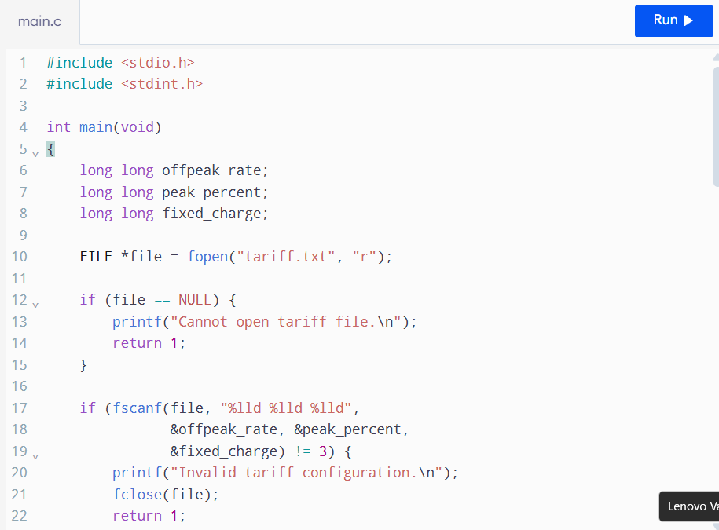
This is a demonstration of runtime tariff loading and peak pricing. For production use, the arithmetic and input validation should be strengthened: in particular, check the multiplication and addition bounds together, handle zero rates explicitly, and avoid casting uint64_t pointers to another type in scanf. A safer implementation reads into unsigned long long variables and then converts validated values to uint64_t.
D. Evidence-Based Defence (2 marks)
The redesigned system is preferable because:
- uint64_t can represent annual energy totals exceeding the 32-bit integer range.
- Integer paise avoids floating-point errors in monetary totals.
- A configuration file allows tariff changes without recompilation.
- Separate peak and off-peak quantities support time-of-day pricing.
- Input validation reduces the risk of incorrect bills.
- Overflow checks are required when calculating district-scale totals.
The design has a small startup cost for reading the tariff file and uses memory for the tariff values. These costs are negligible compared with the benefits of flexible pricing and maintainability.
Final conclusion: The original design should be modified rather than retained unchanged. Wider energy counters, runtime tariff configuration, peak-hour pricing and stronger validation are necessary to support smart-meter billing.

